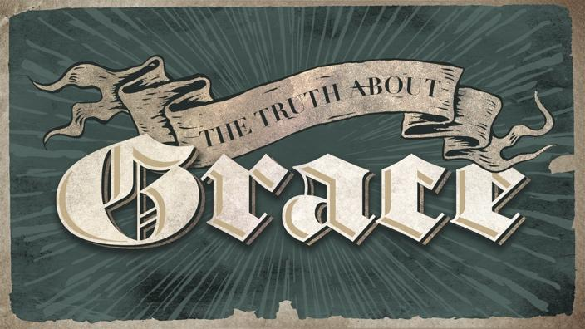

The Truth About Grace, 1 “The Dynamic Duo”
THE BIG IDEA: Freedom is lived out in the balance of grace and truth.

Matthew 22:1-14 (p.691)

The secret sauce of your freedom is GRACE AND TRUTH

The key is to always remain WELL DRESSED
- Matthew 22:11-14 (p.691)

Strategies for the Seasons of Life:
- We have AMAZING seasons and DIFFICULT seasons.
Matthew 16:15-20 (p.687)
Acts 12:5-10 (p.767)

- In the great seasons, DISCOVER Jesus
- In the hard seasons, DECLARE Jesus
Allow God to open the GATE in front of you

Community Group Questions - Truth About Grace – Week 1

- Why is it important to always balance truth with grace?

- What happens when we lean to heavy in either direction?

- How did Jesus model this delicate balance for us? Can you name some examples from scripture?

- What makes a message that is balanced with truth and grace appealing to all audiences?

- What is one new truth that you have discovered about God in a good season?

- What is one way you have had to declare the goodness of God in a difficult season?

- Think of one area in your life where you need to add a little truth or grace into?

